SEG Awards Level 2

Motor Vehicle Studies

Underpinning Knowledge Evidence Record

F/601/6082 Knowledge of Inspection, Testing and Replacement of Vehicle Batteries and Related Components

Learners Name
SEG Awards Registration Number
Centre Name
Assessor 1 Name
Assessor 2 Name

DECLARATION OF AUTHENTICITY

This declaration must be completed and signed by the learner and countersigned by the tutor / assessor and covers all evidence submitted for moderation.

Learner Name
Unique Learner Number (ULN) |  | SEG  Learner Reg. ID
Qualification Title
Centre Name

Learner statement of authenticity

Before signing please read the guidance below.

I confirm, that the attached assignment / portfolio is all my own work and does not include any work completed by anyone other than myself. I have completed the assignment / portfolio in accordance with SEG Awards’ instructions and within the time limits set by my centre.

Signature |  | Date

Centre confirmation of authenticity

On behalf of …………………………………….(insert centre name), I confirm that the above mentioned learner, to the best of my knowledge, is the sole author of the completed assignment / portfolio attached, and the assessments have been completed under the required conditions.

Signed |  | Date
Name
Title

Guidance for Learners

You have been asked to sign this Declaration of Authenticity and place it at the front of your portfolio or course work assessment. It confirms that the work you have submitted for assessment is your own and that you have not copied it from someone else or allowed another learner to copy it from you.

When preparing any course work it is good practice to undertake research using information from published sources. If you quote directly from these sources then this must be indicated in your work by using quotation marks and referencing the document from which the quotation was taken. You must then comment in your own words on any ideas expressed.

Assessors, internal verifiers and SEG Awards’ external moderators and verifiers are subject specialists who can spot the use of published materials that may be passed as your own words or ideas.
If you do copy words from a published source and do not indicate their reference you will be committing plagiarism. This is considered a form of cheating and may result in your assessment being declared void.

Contents

Task No | Title | Assessment Criteria
1 | Hand and specialist tools | 1.1, 1.2
2 | Vehicle charging system | 2.1, 2.2, 2.3, 3.3
3 | Charging system checks | 3.1, 3.2, 3.4, 3.5

Task 1 – Hand and specialist tools | Assessment Criteria 1.1, 1.2

In the table below identify hand and specialist tools used in the inspection, testing and replacement of vehicle batteries, listing the safety checks and explaining how to use the tool safely.
Name of tools | Tool safety checks | Explain how you would use the tool safely

Describe the equipment used to ensure vehicle data is not lost when removing a vehicle battery

Task 2 – Vehicle charging system | Assessment Criteria 2.1, 2.2, 2.3, 3.3

Identify the numbered components of the vehicle charging system below and describe it’s function
Vehicle Charging System | Component Number | Component Function
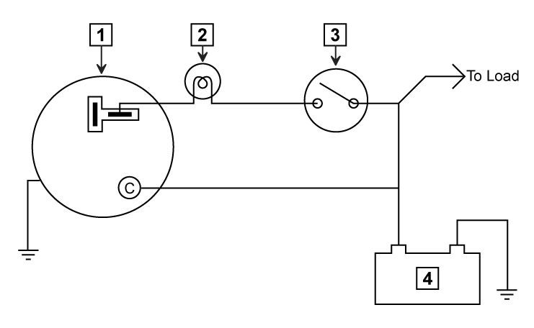 | 1
 | 2
 | 3
 | 4

Describe the importance of selecting the correct battery type and rating for different types of vehicle

Describe the legal requirements relating to storage, selection and disposal of vehicle batteries
Relating to | Legal Requirement
Storage
Selection
Disposal
Replacement

Task 3 – Charging system checks | Assessment Criteria 3.1, 3.2, 3.4, 3.5

Describe the fault identification methods, procedures and rectification with batteries and associated components
Fault | Possible causes and rectification
Noisy drive belt
No warning lamp illumination
No charge
Discharged battery

When carrying out a charging system check what readings would you expect at V and A?
Charging System | No Load Readings at approx 3000 RPM | Full Load Readings at approx 3000 RPM
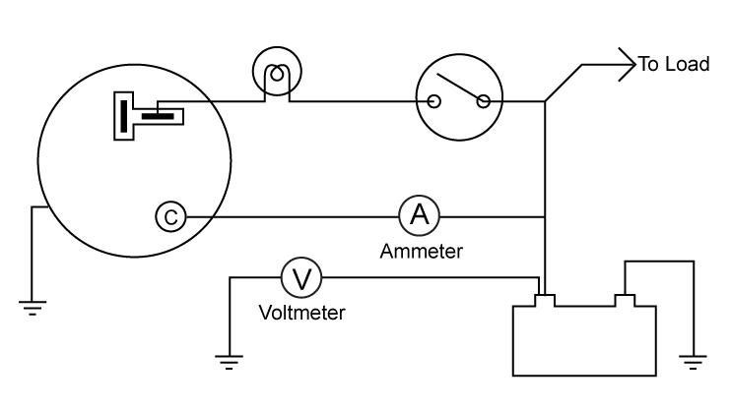

What check should be carried out after replacing a battery or alternator to ensure the charging system is fully serviceable?

Unless otherwise stated e.g. for some entry level qualifications, learners can work together but should identify sections which are their own work.

